**Semi-supervised Domain Adaptation with Instance Constraints**

**摘要：引入，问题，新方法，新方法细节+例子，贡献。**

**介绍：核心概念(领域介绍)，新方法概念(定义、应用场景、阐释)，新方法核心算法框架，文章框架。**

**Problem:**

For domains where labels are limited, simply borrowing labeled data from existing datasets can hurt performance, a phenomenon known as “dataset bias.”

对于标签有限的域，仅从现有数据集中借用标签数据会损害性能，这叫“数据集偏差”。

**Solution – Novel framework:**

we present a unified domain adaptation framework that incorporates both traditional labels and unlabeled instance constraints. 领域自适应新框架融合了传统标签和无标签样本约束。

**Domain Adaptation:**

Test examples differ significantly from the examples used for learning.

领域自适应：“测试样本” 明显不同于“ 学习样本” 。

**Instant constraints:**

Available over the unlabeled target data, encoding the knowledge that certain samples belong to the same object instance, and thus should be classified in a similar way.

样本约束用于无标签目标数据，对属于相同目标样本的特定样本进行知识编码，以分到相似的类别中。

**Performance Comparison:**

Algorithm with using adaptation with instance constraints (better)

Algorithm without using adaptation with instance constraints

Algorithm with no adaptation

**Design of Algorithm:**

Original learning framework (regularizer+optional transformation parameter, scalar parameters+loss function):

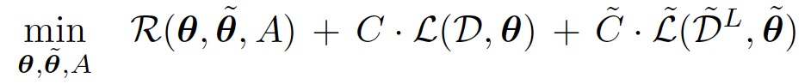

**Manifold regularization** (Laplacian regularizer: restrict the target f(x) to have similar values for similar instances, similarity constraints over the unlabeled target data. The Laplacian term is convex in the parameters, for a robust optimization with gradient & convergence.)

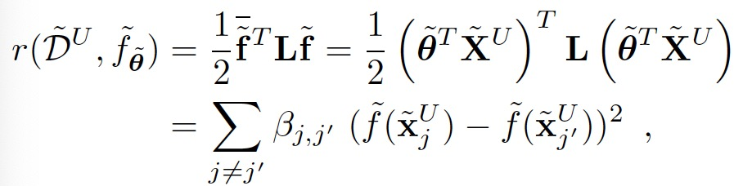

Integrate Laplacian regularizer (similarity constraints) into domain adaptation models:

PMT-SVM (regularizer):

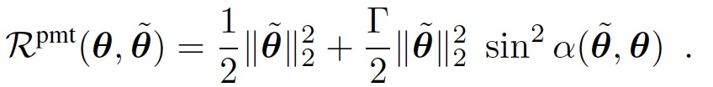

transformed-based domain adaptation:

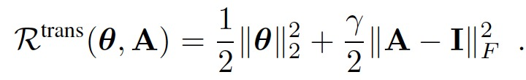

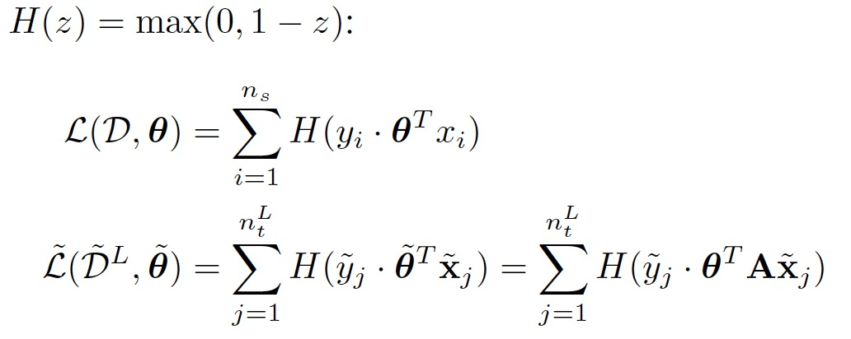

**Optimization framework:**

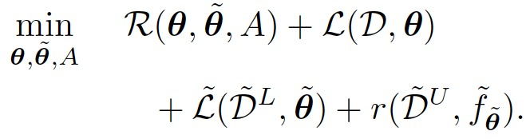

Multi-category adaptation:

